ACCOUNTS RECEIVABLE DASHBOARD – SETUP GUIDE

You’ll be up and running in a few minutes.
No technical setup required — just paste your data and click refresh.
Setup time: ~5 minutes
Daily use: ~2 minutes

How it works (quickly)
- Paste your data into Excel
- Open the dashboard
- Click Refresh

Before you start
You only need:
- Power BI Desktop (free, Windows) (Link)
- Microsoft Excel
- Your invoice data (from Xero, MYOB, QuickBooks, etc.)

Step 1 - Open the Excel template
Open:
AR_Dashboard_Template.xlsx
This is the Excel template that you should be using to populate your data. Example screenshot below on how the file would appear on your own saved location.

Step 2 - Replace the sample data
- You’ll see sample data in the file.
- Delete the sample data
- Paste your own customer invoice data
Keep these unchanged:
- Column names
- Table name (ReceivablesTable)

Step 3 - Save the file
Save it somewhere easy to find.

Step 4 - Open the Power BI dashboard
Open the .pbix file. This file is called ‘AR Dashboard’. Simply double click the file to open it with Power BI.
Allow a few seconds for the required setup to load. The file will bydefault load in the Report view and you will see the visuals from the sample data

Step 5 - First-time setup (only once)
This step is only needed once.
Click on ‘Refresh’. You will see an error message saying the Excel Template that you populated cannot be found.
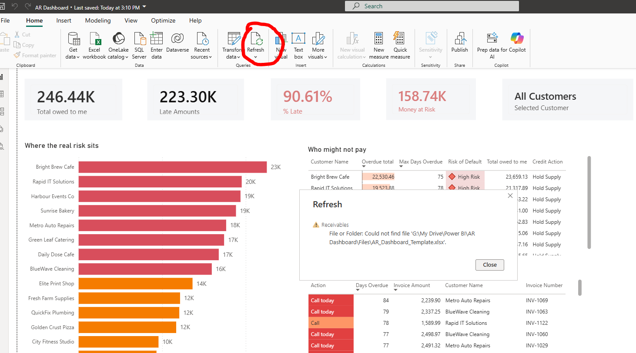
This is normal — it just means Power BI needs to know where your Excel file is saved.

Follow the actions and screenshots below. You only need to do this once and Power BI will remember the location from the next time onwards
- Click Transform Data
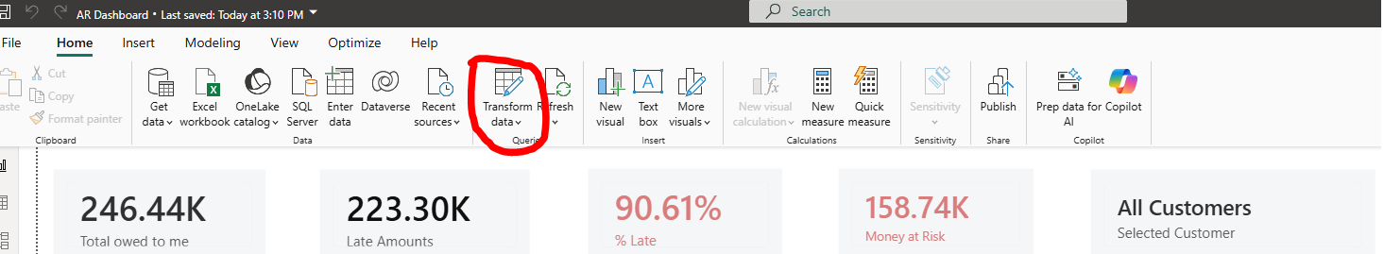
- In the new window that opens, Click Data source settings
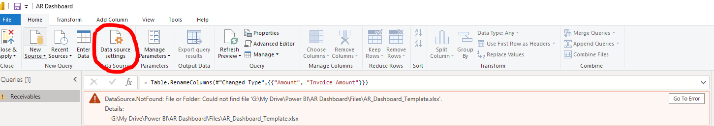
- Click on the Excel file path and then click Change Source
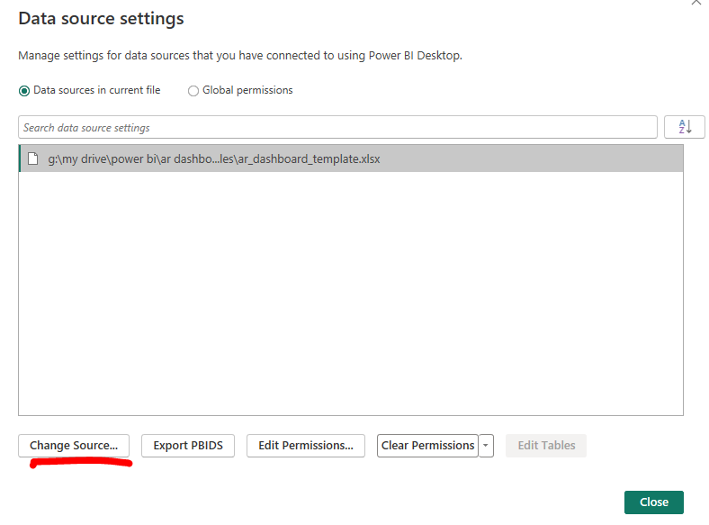
- Use the Browse button, locate your Excel Template and then select OK:
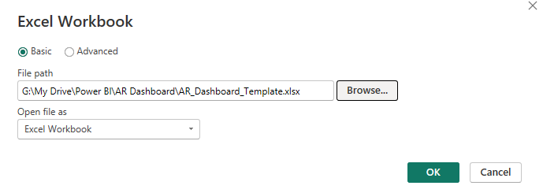
- Click Close on the Data Source Settings
- Click Close and Apply
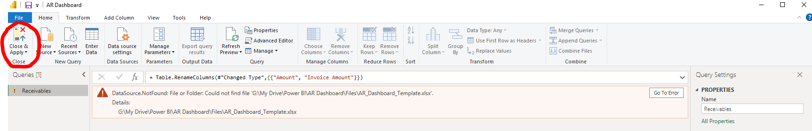
- You will see Power BI working to load your table. Once refreshed, you will see the visuals changing with your own data

Step 6 — Daily use
Once Step 5 is done for the first time, from the second time onwards, all you need to do is;
- Open the Excel Template
- Replace the Data and save the file
- Open the pbix file (Step 4)
- Click on Refresh
The dashboard will be refreshed with your latest Accounts Receivable situation

Important
To keep everything working:
- Do not change column names
- Do not rename the table (ReceivablesTable)
- Do not import a new file into Power BI

If something doesn’t work
- Make sure the Excel file is saved
- Check column names
- Click Refresh again

That’s it
Open → update → refresh → act.

